Diagrams:
ItemTracker Class:
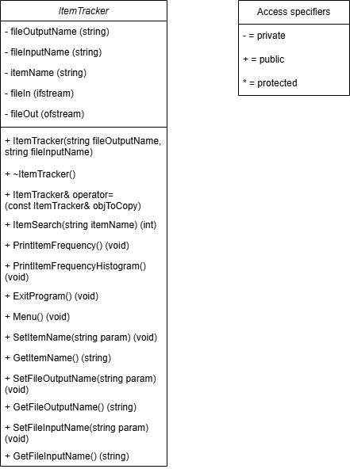

ItemTracker System:
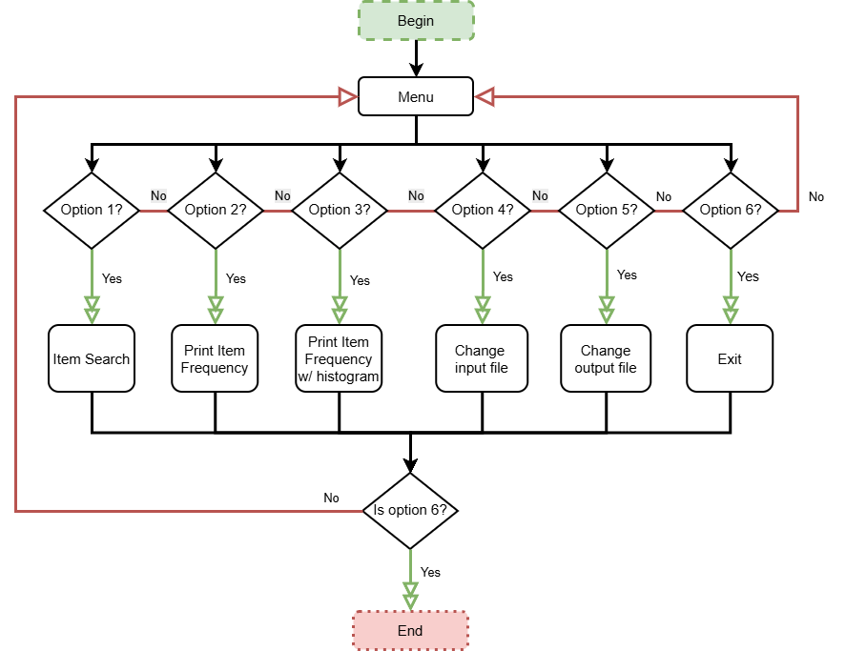

ItemTracker Search Option:
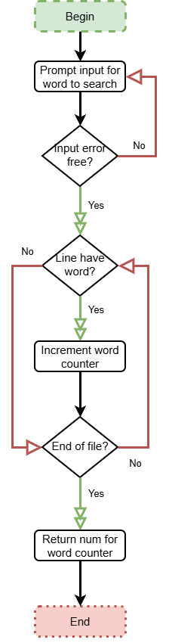

ItemTracker Print Item Frequency option:
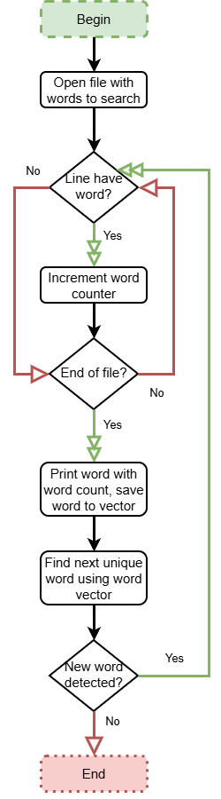

ItemTracker Search Histography Option:
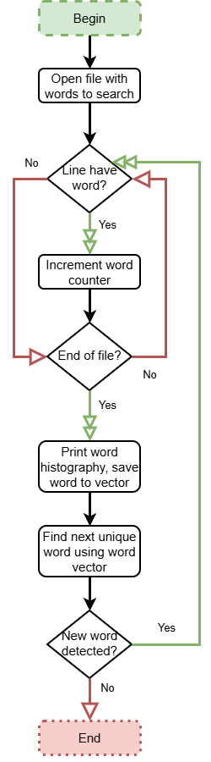
NOTE: I decided not to make a UML for all the options for the menu in the ItemTracker class since some of them are not very complex and are self-explanatory to developers. The ItemTracker class is meant to be designed to work with files.
How I developed this program:
12/09/2025:
I worked on the UML diagrams: the ItemTracker class and the flowcharts describing the important parts of how the class methods should work. A friend of mine (he/name used interchangeably every time mentioned) helped me with the overall aesthetic of diagrams to try to make them more accessible and easier to understand. There weren’t any changes from my original design.
12/10/2025:
First, I used the class diagram as a reference to at least get the class structured. I used a file separation technique to divide the class into two connected parts to improve performance by reducing the main file’s copy size and improve understandability by separating the class structure from its implementation, providing a brief summary of what it does. I also added preprocessor directives called header file guards to the header file to prevent potential operation-time errors where a header file may be included multiple times.
12/10/2025 at 8:38 PM EST:
I’ve decided to take a break after setting up the overall structure of the class after doing a quick test on calling the most important methods in the class in Menu(). I plan on adding more functionality to each method, especially the more complex ones. So far, I think the most difficult parts are going to be working with file output/input streams and creating the algorithm logic for the item frequency and the histogram version of it. Thankfully, I believe one of the methods related to item searching can be reused and the algorithms are somewhat similar according to my design diagrams.
I am contemplating on whether or not to divide sections of the Menu() method into smaller functions/methods of the same class type. I haven’t done the bare minimum in my opinion in the developing part of the program, but I still feel accomplished that I developed most of the structural parts of the class. I separated the class method/function names (ItemTracker.h) from the class method/function bodies (ItemTracker.cpp) and implemented the header file guards into ItemTracker.h.
12/11/2025 at 9:25 PM EST:
I decided to take a break on developing the ItemTracker project. I worked on the Menu() method and implemented the ItemSearch() method. I decided to go with the approach of declaring if/ofstream class objects inside each class method when relevant instead of as private class attributes to avoid any potential leaks. The overall design structure is fairly similar in each method that requires input and output file streaming. In fact, I suspect I can reuse ItemSearch() in at least two methods. I just need to figure out how to implement the design. I think I need to update the ItemTracker class diagram to match the changes I made.
Note to self: Update class diagram and possibly some of the flowcharts
12/12/2025 at 6:59 PM EST:
For now, I think I am finished with the ItemTracker class. If I had more time, I think I would have included unit testing using a testbench and used more try-catch blocks for exception handling. I think if I ever decide to work on this class some more, I would redesign parts of the ItemTracker class to more efficient, adaptive, and understandable. I’d also consider updating the ItemTracker class to handle multiple input files and output files and learning to send data between different computers. The Menu() class is a bit inflated and I might end up simplifying it in the future. I also need to learn more about the C++ standard template library Map and practice with it a bit more so I utilize maps more effectively in the future. Although I feel a little disappointed and feel that I could’ve done better, I think I did very well given the circumstances and short time limit.

